CAR RENTAL WEBSITE

Project report submitted in partial fulfilment of the requirement for the award of the Degree of

### Bachelor of Computer Application

BY

**Satyam kulshreshtha**

**Roll no: 677758**

**Enrollment no.: 20/108306**

**Session:** 2020-2023





### Maharishi Arvind Institute of Science and Management Jaipur University of Rajasthan

**Jaipur**

**CERTIFICATE**

This is to certify that the project report entitled **"Car Rental Website"** submitted by **Mr. Satyam Kulshreshtha** in partial fulfillment for the award of the Degree of Bachelor of Computer Application **(BCA)** to the University of Rajasthan, represents a bona fide work carried out by our group.

We hereby affirm that this project report is an original work undertaken by us, and it meets the necessary requirements and standards for the award of the Degree of Bachelor of Computer Application (BCA).

|  |  |
| --- | --- |
| **Mr. Sunil Chauhan** | **Mr. Vijay Sharma** |
| (Head of Department) | (Assistant professor) |
| Computer Science  Maharishi Arvind institute  Of Science and management | Computer Science  Maharishi Arvind institute  Of Science and management |

# DECLARATION

This is to certify that the work report in the present project entitled

**“Car Rental Website”** is a record of work done by our group in the

Department of Computer Science, **Maharishi Arvind Institute of Science & Management**. The reports are based on the project work done entirely by us and not copied from any other source.

We hereby declare that the results embodied in this project report have not been submitted to any other University or Institute for the award of any Degree or Diploma. All the information and data presented in this report are authentic and accurately represent the work conducted by our team.

We acknowledge that this project was self-guided, and we have undertaken it independently, leveraging our collective knowledge and skills in the field of computer application. Throughout the development process, we have conducted thorough research, designed and implemented the project requirements, and resolved any challenges encountered along the way.

**Satyam Kulshreshtha**

**Roll no: 677758**

**Enrollment No.: 20/108306**

**Class: BCA 3rd year**

**Session: 2020-2023**

**ACKNOWLEDGEMENT**

We would like to express our heartfelt gratitude to the individuals who have been instrumental in the successful completion of this project.

First and foremost, we extend our sincere appreciation to our family and friends for their unwavering support and encouragement throughout this endeavor. Their belief in our abilities and constant motivation have been invaluable in overcoming challenges and achieving the project's objectives.

We would also like to express our deep appreciation to the faculty members of Computer science department for their continuous guidance and the comprehensive academic curriculum that has laid a strong foundation for this project.

The availability of research papers, online forums, and open-source libraries has been invaluable in tackling technical challenges and broadening the scope of this project.

In conclusion, we extend our heartfelt thanks to all those mentioned above for their unwavering support, guidance, and encouragement. Their contributions have been crucial in the successful completion of this project.

--------------------------------

**Mr. Satyam Kulshreshtha**

(BCA 3rd year 2020 - 2023)

**Table of Contents**

|  |  |  |
| --- | --- | --- |
| **S.no.** |  | **Particulars** |
| **1** |  | Introduction |
|  | **1.1** | Project overview |
|  | **1.2** | Objectives |
|  | **1.3** | Scope and Limitations |
| **2** |  | Tools and Technology used |
|  | **2.1** | HTML |
|  | **2.2** | CSS |
|  | **2.3** | JAVASCRIPT |
|  | **2.4** | JQUERY |
|  | **2.5** | BOOTSTRAP |
|  | **2.6** | JAVA EE |
|  | **2.7** | JVM |
|  | **2.8** | JDBC |
|  | **2.9** | EJB |
|  | **2.10** | API |
|  | **2.11** | HTTP |
|  | **2.12** | CRUD |
|  | **2.13** | MYSQL |
|  | **2.14** | TOMCAT |
| **3** |  | System Requirements |
|  | **3.1** | Hardware Requirements |
|  | **3.2** | Software Requirements |

**Table of Contents**

|  |  |  |
| --- | --- | --- |
| **S.no.** |  | **Particulars** |
| **4** |  | User Interface Design |
| **5** |  | Database Design |
| **6** |  | Backend Development |
|  | **6.1** | Java Servlets |
|  | **6.2** | Java Server Pages (JSP) |
|  | **6.3** | Enterprise JavaBeans (EJB) |
|  | **6.4** | Business Logic Implementation |
|  | **6.5** | Integration with Database (JDBC) |
|  | **6.6** | Handling User Requests and Data Processing |
| **7** |  | Testing |
| **8** |  | Conclusion |
| **9** |  | Reference |

**INTRODUCTION**

**Car Rental Website project (Rentalgo.com)**



The Car Rental Website project utilizes a variety of technologies including HTML, CSS, JavaScript, jQuery, Bootstrap, Java EE, JSP, JDBC, API, EJB, and HTTP. This web-based application aims to provide an intuitive and user-friendly platform for online car rentals.

With the increasing demand for convenient and flexible car rental services, our website serves as a bridge between car rental agencies and customers. Users can easily browse available cars, make reservations, manage bookings, and access relevant information.

The website's interface is visually appealing and responsive, designed using HTML, CSS, and Bootstrap. Interactive features and dynamic functionality are implemented using JavaScript and jQuery.

On the server-side, Java EE technologies such as JSP, JDBC, and EJB are employed. JSP generates dynamic web content, while JDBC ensures seamless database connectivity for managing car inventory, user details, and reservations. The integration of APIs enhances the website's capabilities to provide mailing services for booking confirmations message.

**Project Overview**

The Car Rental Website project is a web-based application that aims to provide a user-friendly platform for renting cars online. With the increasing demand for convenient and flexible car rental services, the project aims to bridge the gap between car rental agencies and customers by offering a seamless and efficient online booking system.

The main objective of the project is to create a user-friendly website where customers can easily browse through a wide range of available cars, make reservations, manage bookings, and access relevant information. The website will provide a visually appealing and responsive interface, ensuring a smooth user experience across various devices.

The project utilizes a range of technologies including HTML, CSS, JavaScript, jQuery, Bootstrap, Java EE, JSP, JDBC, API, EJB, and HTTP. These technologies are employed to implement interactive features, dynamic functionality, database connectivity, and integration with external services.

Key features of the Car Rental Website include an intuitive user interface, real-time availability of cars, secure online payments, reservation management, and seamless integration with external APIs for additional services such as GPS navigation or insurance options.

Throughout the development process, careful attention will be given to user experience, system performance, and data security. Extensive testing will be conducted to ensure the website functions smoothly and meets the requirements of both car rental agencies and customers.

The project aims to deliver a comprehensive and user-friendly car rental solution that simplifies the rental process, enhances customer satisfaction, and provides a seamless online platform for car rental services.

**Objectives**

1. Develop a user-friendly website that allows customers to easily browse, select, and book rental cars online.
2. Implement a responsive design to ensure the website is accessible and functions seamlessly across various devices and screen sizes.
3. Create a convenient and straightforward booking process for customers, enabling them to make reservations with ease.
4. Enable customers to view their booked reservations and provide them with the necessary information for pickup and return.

5. Enhance the user experience through a user-friendly interface, intuitive navigation, and clear presentation of rental car details.

1. Implement a reliable database system to store and manage car inventory, customer details, and booking information.

7. Ensure a secure and encrypted connection for customer data and transactions.

8. Provide comprehensive documentation and support materials to assist users in navigating and using the website effectively.

**Scope and Limitations**

**Scope:**

**1**. The Car Rental Website will provide an online platform for customers to browse and book rental cars.

**2**. The website will have a user-friendly interface for users who want to rent a car. Customers will be able to create accounts, and book the car of their choice.

**3**. The website will provide customers with information on rental car pricing and they will be able to make bookings without making online payments.

**4**. The website will be designed to be responsive and accessible across different devices and screen sizes.

**5**. Proper database management will be incorporated to store and retrieve car inventory, customer data, and booking information.

**6**. The project will focus on usability and user experience, ensuring a smooth and intuitive interface for customers.

**Limitations:**

**1.** The Car Rental Website will not include features for real-time car availability. Customers will be able to make bookings based on the available cars listed at the time of their search.

**2.** The website will not provide additional services such as GPS navigation, insurance options, or loyalty programs.

**3.** The project will not involve integrating external APIs for location-based services or other third-party services.

**4.** The website will not provide payment gateway and additional advanced security features such as two-factor authentication or fraud detection.

**5.** The project will focus on the core functionalities of car browsing, booking without extensive customization options.

**6.** Multilingual support may not be included in the initial scope of the project.

# Tools and Technologies Used

# HTML (Hypertext Markup Language):

# HTML is the standard markup language used for structuring and presenting content on the web. In the Car Rental Website project, HTML is used to create the structure and layout of web pages, defining the elements and their arrangement.HTML played a vital role in the development of the car rental website. It was used to create the fundamental structure and layout of each webpage. HTML tags were employed to define headings, paragraphs, lists, forms, tables, and other essential elements. By structuring the content in a semantically meaningful way, HTML ensured that the website was accessible, well-organized, and easily understood by both users and search engines.

# CSS (Cascading Style Sheets):

# CSS is a stylesheet language used for describing the presentation and appearance of HTML documents. It is used in the project to style the web pages, including defining colors, fonts, layouts, and other visual aspects of the website.CSS was utilized to enhance the visual appearance and user experience of the car rental website. By defining styles and applying them to HTML elements, CSS controlled the layout, colors, fonts, spacing, and other visual aspects of the website. Custom CSS styles were implemented to create a cohesive and visually appealing design, ensuring a consistent look and feel across all pages. Additionally, CSS media queries were used to make the website responsive and adaptable to different screen sizes and devices.

# JavaScript:

# JavaScript is a programming language used for adding interactivity and dynamic behavior to web pages. In the project, JavaScript is employed to enhance the user experience by implementing features such as form validation, dynamic content updates, and interactive elements.JavaScript played a crucial role in adding interactivity and dynamic functionality to the car rental website. It was used to handle user interactions and events, such as validating form inputs, displaying dynamic content, and performing calculations. JavaScript enabled the implementation of interactive features, such as dropdown menus, image sliders, and client-side form validation. It also facilitated the integration of third-party libraries and APIs to enhance the website's capabilities and provide a more interactive user experience.

# jQuery:

# jQuery is a JavaScript library that simplifies and enhances JavaScript's functionality. It provides a wide range of pre-built functions and features, making it easier to manipulate HTML documents, handle events, perform animations, and make AJAX requests. jQuery is used in the project to streamline and simplify JavaScript coding tasks.

# jQuery, a popular JavaScript library, was leveraged to simplify and streamline the JavaScript code in the car rental website project. It provided a wide range of pre-built functions and utilities, allowing developers to write concise and efficient code. jQuery was used for tasks such as DOM manipulation, event handling, AJAX requests, and animation effects. By utilizing jQuery, the development process was accelerated, and the overall codebase became more maintainable and robust.

# Bootstrap:

# Bootstrap is a popular front-end framework that provides a set of pre-designed CSS and JavaScript components. It offers a responsive grid system, CSS styles, and interactive components that enable rapid website development. The Car Rental Website project uses Bootstrap to create a responsive and visually appealing layout, ensuring a consistent design across different devices.

# Bootstrap, a powerful front-end framework, played a significant role in developing a responsive and mobile-friendly car rental website. It provided a collection of pre-designed and customizable components, such as navigation menus, buttons, forms, and modal windows. The built-in grid system in Bootstrap facilitated the creation of a responsive layout that automatically adjusted to different screen sizes. By using Bootstrap, the development process was streamlined, and the website's responsiveness and user experience were improved.

# Java EE (Java Enterprise Edition):

# Java EE is a platform for developing enterprise-level Java applications. In the Car Rental Website project, Java EE is used to build the server-side components, implement business logic, manage database connections, and handle the communication between the client and server.

# Java EE was employed to build the backend of the car rental website, handling server-side processing and business logic. It provided a robust and scalable platform for developing enterprise-level web applications. Java EE technologies such as Java Servlets, JavaServer Pages (JSP), and Enterprise JavaBeans (EJB) were utilized to handle user requests, interact with databases using JDBC (Java Database Connectivity), and implement server-side functionality. Java EE's modular and component-based architecture allowed for the development of a flexible and maintainable backend system.

# These technologies, combined together, enabled the development of a fully functional and visually appealing car rental website. By utilizing HTML, CSS, JavaScript, jQuery, Bootstrap, and Java EE, the project team created a seamless user experience with interactive features, responsive design, and efficient backend processing.

# JVM (Java Virtual Machine):

# JVM is the virtual machine that executes Java bytecode. It is responsible for running Java applications, including the Car Rental Website project, by translating the bytecode into machine-specific instructions.

# JVM, or Java Virtual Machine, is a crucial component in Java-based applications. It provides a runtime environment for executing Java bytecode, allowing the car rental website project to run on different operating systems and hardware platforms. The JVM manages memory, handles garbage collection, and provides other runtime services, ensuring the smooth execution of the Java code powering the website.

# JDBC (Java Database Connectivity):

# JDBC is an API that enables Java applications to interact with databases. It provides a set of classes and interfaces for connecting to a database, executing SQL queries, and managing the retrieval and storage of data. JDBC is used in the project to establish a connection with the MySQL database and perform database operations, such as retrieving car inventory and customer information.

# JDBC, short for Java Database Connectivity, is a Java API that enables interaction with relational databases. In the car rental website project, JDBC was used to establish a connection between the Java backend and the MySQL database. It provided a set of classes and methods to execute SQL queries, retrieve and update data, and manage database transactions. JDBC allowed seamless integration with the MySQL database, enabling efficient storage and retrieval of car rental information.

# EJB (Enterprise Java Beans):

# EJB is a server-side component architecture in Java EE for developing scalable and distributed enterprise applications. In the Car Rental Website project, EJB may be used to encapsulate business logic, manage transactions, and handle complex operations involving multiple components.

# EJB, or Enterprise JavaBeans, is a server-side component architecture provided by Java EE. It facilitates the development of scalable and distributed enterprise applications. In the car rental website project, EJB technology was employed to implement business logic and manage transactions. EJB components, such as session beans and entity beans, were used to handle complex business operations, such as booking reservations, managing customer data, and processing payments.

# HTTP (Hypertext Transfer Protocol):

# HTTP is the protocol used for transferring data over the web. It defines the rules and conventions for communication between clients (web browsers) and servers. In the project, HTTP is used for client-server communication, enabling the exchange of requests and responses between the Car Rental Website and its users.

# HTTP, or Hypertext Transfer Protocol, is the protocol used for transmitting data over the internet. In the car rental website project, HTTP was employed for communication between the web browser and the web server. HTTP requests and responses were used to transfer data, such as user input, form submissions, and server-generated content. By leveraging HTTP, the car rental website could deliver dynamic and interactive web pages to users.

# CRUD (Create Read Update Delete):

# CRUD represents the basic operations performed on data in a database. It stands for Create, Read, Update, and Delete, which are essential actions for managing records. In the Car Rental Website project, CRUD operations are used to create new car listings, retrieve car details for users, update booking information, and delete records when necessary.

# CRUD is an acronym that represents the four basic operations performed on data in a database: Create, Read, Update, and Delete. In the context of the car rental website project, CRUD operations were implemented using Java and the MySQL database. They allowed users to create new car rental listings, view existing listings, update listing details, and delete listings. CRUD operations formed the foundation for managing the data and providing a seamless user experience.

# MySQL:

# MySQL is an open-source relational database management system (RDBMS) widely used in web applications. In the project, MySQL is used to store and manage car inventory, customer data, and booking information, providing a reliable and scalable data storage solution.

# MySQL is a popular open-source relational database management system. In the car rental website project, MySQL was used as the database to store and retrieve data related to car listings, user information, and booking details. The Java backend communicated with the MySQL database using JDBC, executing SQL queries to perform database operations efficiently and securely.

# Tomcat:

# Apache Tomcat is an open-source web server and servlet container that supports Java-based web applications. In the project, Tomcat may be used to deploy and run the Car Rental Website, providing the necessary environment for executing Java EE components and serving web pages to users.

# Tomcat is an open-source web server and servlet container that implements the Java Servlet and Java Server Pages (JSP) technologies. In the car rental website project, Tomcat was used to host and deploy the Java web application. It provided the runtime environment for executing the Java code, handling HTTP requests, and serving web pages to users. Tomcat ensured the smooth operation and accessibility of the car rental website over the internet.

# These tools and technologies collectively contribute to the development and functionality of the Car Rental Website project, enabling the creation of dynamic web pages, interaction with databases, implementation of business logic, and providing an enhanced user experience.

**System Requirements:**

To run the car rental website smoothly, the following system requirements should be met:

**1. Hardware Requirements:**

**- Processor:** A modern multi-core processor, such as Intel Core i5 or AMD Ryzen, is recommended for handling concurrent user requests and database operations efficiently.

**- Memory (RAM):** Minimum of 8GB RAM is recommended to ensure smooth performance, especially when dealing with large datasets and complex operations.

**- Storage:** Adequate storage space should be available to accommodate the website files, database, and any additional resources. Solid-state drives (SSD) are preferred for faster read/write operations.

**- Internet Connection:** A stable broadband internet connection with reasonable upload and download speeds is necessary for hosting the website and ensuring smooth user interactions.

**2. Software Requirements:**

**- Operating System:** The car rental website is compatible with various operating systems, including Windows, macOS, and Linux. Ensure that the chosen operating system is up-to-date with the latest patches and updates.

**- Web Browser:** The website is designed to be compatible with popular web browsers like Google Chrome, Mozilla Firefox, Microsoft Edge, and Safari. It is recommended to use the latest versions of these browsers to ensure compatibility and take advantage of the latest web technologies.

**- Java Development Kit (JDK):** Install the latest version of JDK to compile and run Java code. Ensure that the JDK is properly configured, and the PATH environment variable is set accordingly.

**- Integrated Development Environment (IDE):** A Java IDE such as Eclipse, IntelliJ IDEA, or NetBeans is recommended for efficient development, debugging, and project management. These IDEs provide features like code completion, syntax highlighting, and version control integration.

**3. Web Server:**

**- Apache Tomcat:** Install and configure Apache Tomcat, a popular Java-based web server and servlet container, to host and deploy the car rental website. Apache Tomcat provides support for Java Server Pages (JSP) and Java Servlets, which are essential components of the website.

**4. Database:**

**- MySQL Database:** Install and set up MySQL, a robust relational database management system, to store and manage the website's data. Ensure that the necessary JDBC drivers are installed and configured for the Java application to connect to the MySQL database. Optimize the database by indexing frequently accessed fields and using appropriate data types for efficient storage and retrieval of data.

**User Interface Design:**

The user interface (UI) design of the car rental website is a crucial aspect that focuses on creating an immersive and delightful user experience. The following details elaborate on the key components and considerations in the UI design:

**Design Principles:**

Design principles are fundamental guidelines that help create visually appealing and user-friendly interfaces. In the context of the car rental website, the following design principles are applied:

**1. Simplicity:**

The design follows the principle of simplicity, keeping the interface clean and uncluttered. Unnecessary elements are minimized, and only essential components are included to avoid overwhelming the users with excessive information or options.

**2. Consistency:**

Consistency is maintained throughout the website, ensuring that elements such as buttons, icons, and typography remain consistent across pages. This consistency enhances usability and helps users navigate and interact with the website more efficiently.

**3. Hierarchy:**

The design utilizes visual hierarchy to prioritize and organize information effectively. Important elements such as headings, titles, and call-to-action buttons are given prominence through size, color, and placement, making it easier for users to understand the structure and flow of the content.

**Layout and Structure:**

The layout and structure of the car rental website play a crucial role in presenting information and guiding users through the interface. The following aspects are considered in the layout and structure design:

**1. Grid System:**

A grid-based layout is employed to create a balanced and structured design. The use of grids ensures consistency in the placement of elements and helps establish alignment, making the website visually appealing and easy to navigate.

**2. White Space:**

Ample white space is incorporated between elements to enhance readability and create a sense of visual breathing room. White space also improves the overall aesthetics of the design, allowing important elements to stand out.

**Color Scheme and Typography:**

The choice of color scheme and typography greatly influences the visual impact and readability of the website. Here's how these aspects are addressed:

**1. Color Scheme:**

A carefully selected color scheme is employed to create a visually pleasing and harmonious design. Colors are chosen based on the brand identity and to evoke emotions such as trust, confidence, and friendliness. The color scheme is consistent throughout the website to maintain a cohesive look and feel.

**2. Typography:**

Thoughtful typography choices are made to ensure readability and reinforce the brand personality. Fonts with appropriate weights, sizes, and styles are selected to enhance legibility and maintain consistency across different sections of the website. A combination of headings and body text fonts is used to establish a hierarchy and guide users' attention.

**Navigation and Menus:**

Navigation and menus are vital components that facilitate easy exploration and access to different sections of the website.

The following considerations are taken into account:

**1. Clear and Intuitive Navigation:**

A clear and intuitive navigation system is implemented, ensuring that users can easily find their way around the website. The navigation menu is prominently placed, with clear labels and logical grouping of menu items. It is designed to be user-friendly and accessible across different devices.

**2. Dropdown Menus and Sub-Menus:**

Dropdown menus and sub-menus are used to organize content and provide a hierarchical structure when necessary. This allows for efficient categorization and navigation within the website's various sections and subpages.

**Visual Elements and Images:**

Visual elements and images play a vital role in enhancing the user experience and conveying information effectively. The following approaches are employed:

**1. Relevant and High-Quality Images:**

High-quality images are carefully selected to showcase the cars, rental locations, and other relevant visual content. These images help users visualize the offerings and create an emotional connection with the website.

**2. Consistent Visual Styling:**

Visual elements such as icons, buttons, and graphics are designed consistently to maintain a cohesive and professional look. Consistent styling ensures that users can easily identify interactive elements and understand their purpose throughout the website.

**Intuitive Navigation:**

The navigation system is designed to be intuitive and user-friendly. A well-structured navigation menu is implemented, allowing users to easily navigate to different sections and pages of the website. Clear and concise labels are used to describe the menu items, ensuring users can find what they are looking for without confusion. Additionally, a breadcrumb trail is incorporated to provide users with a sense of their current location within the website hierarchy.

**Responsive Design:**

The website is designed to be responsive, ensuring optimal display and functionality across various devices and screen sizes. Responsive design techniques, such as fluid layouts, flexible images, and media queries, are employed to adapt the website's appearance and layout to different devices, including desktops, laptops, tablets, and smartphones. This enables users to access the website and perform actions seamlessly from any device they prefer.

**Interactive and Engaging Elements:**

The UI design incorporates interactive elements to engage and captivate users. This includes features like image sliders, car image galleries, interactive maps to showcase car rental locations, and tooltips to provide additional information or guidance. These interactive elements add a dynamic and immersive experience, enhancing user engagement and encouraging them to explore and interact with the website.

**Forms and User Input:**

User input forms are designed with usability and efficiency in mind. The forms are carefully structured, with clear labels and placeholders for each input field. Proper validation is implemented to ensure that users provide accurate and valid information. Real-time feedback is provided for input validation, helping users identify and correct any errors promptly. Additionally, the forms are optimized for easy completion on both desktop and mobile devices.

**Consistency and Accessibility:**

The UI design maintains consistency throughout the website, ensuring a seamless user experience. Consistent placement of navigation elements, buttons, and visual styling elements across pages creates a sense of familiarity and ease of use. Accessibility considerations are also taken into account, with appropriate contrast ratios for text and visual elements, alternative text for images, and keyboard accessibility to ensure that the website is usable by a wide range of users.

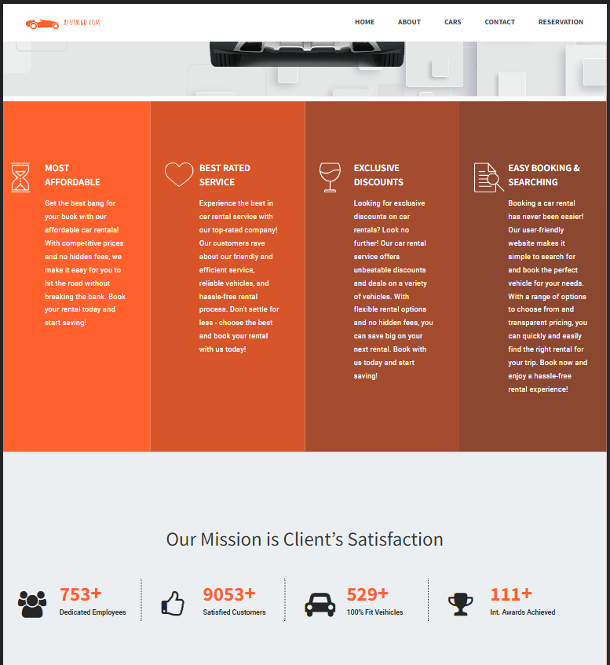**User Interface Images**

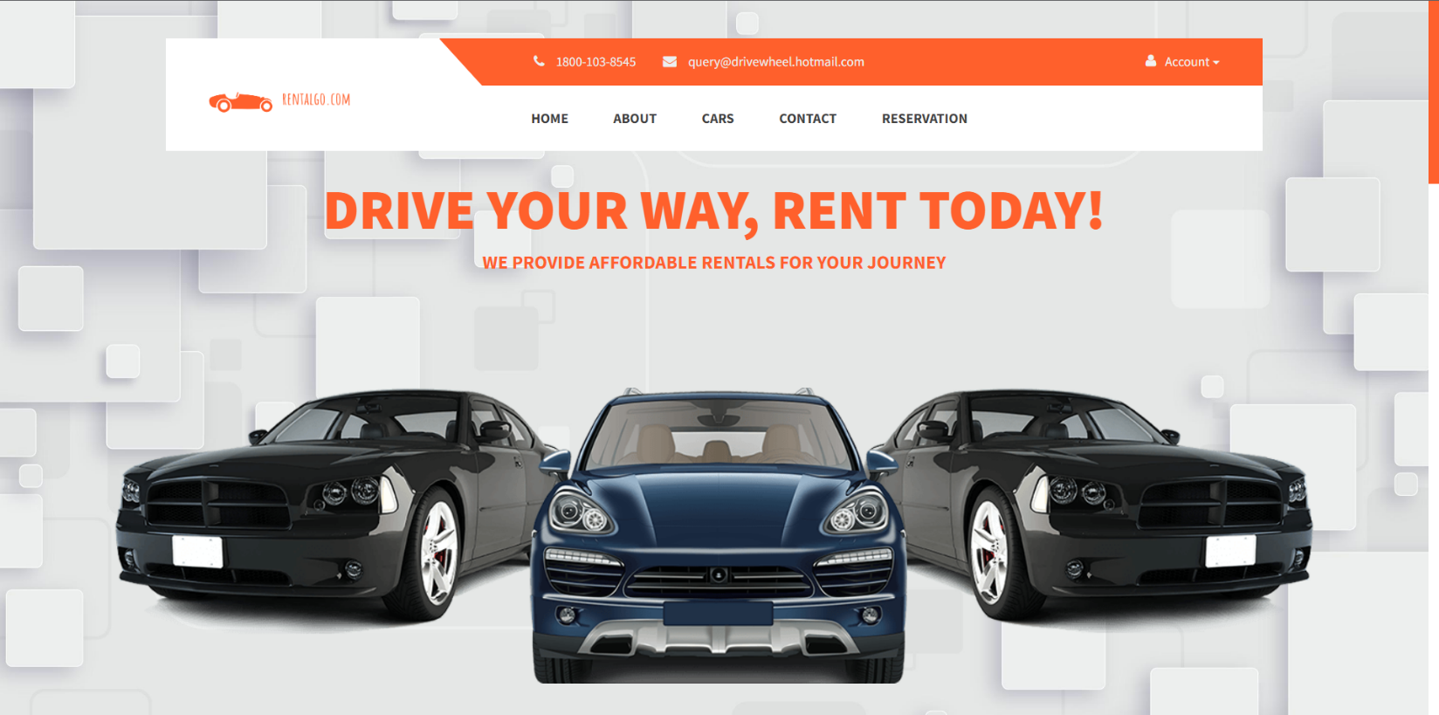**Home Page**

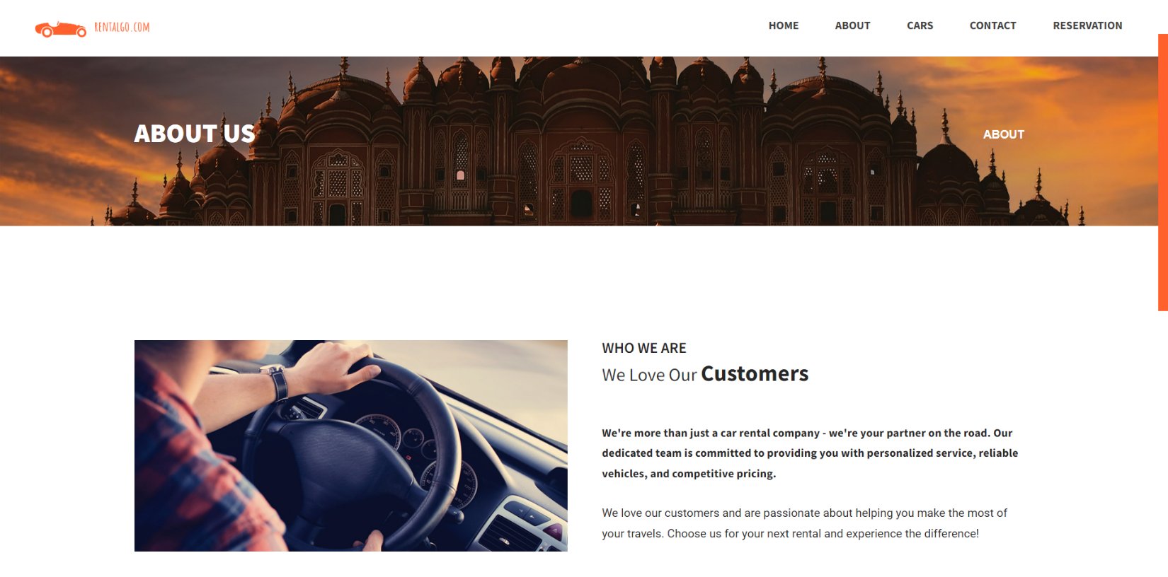**About Page**

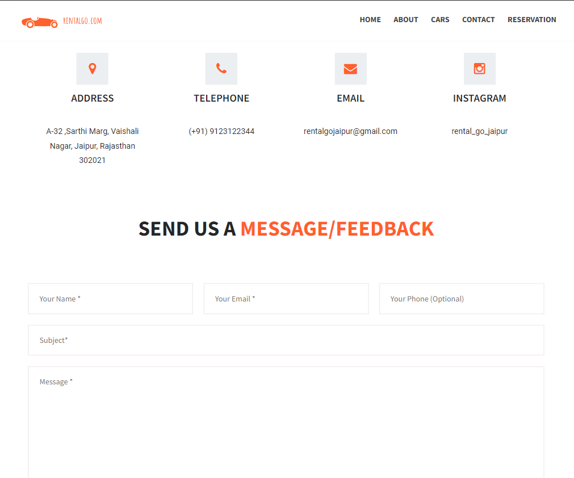**Contact Page**

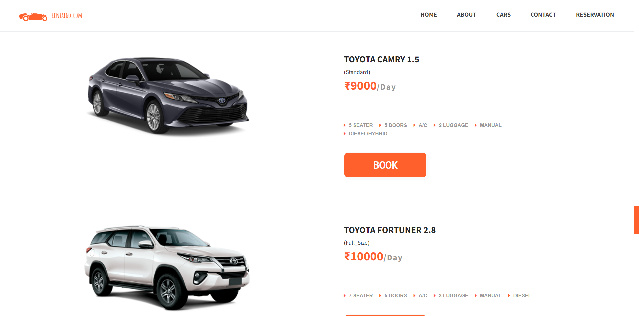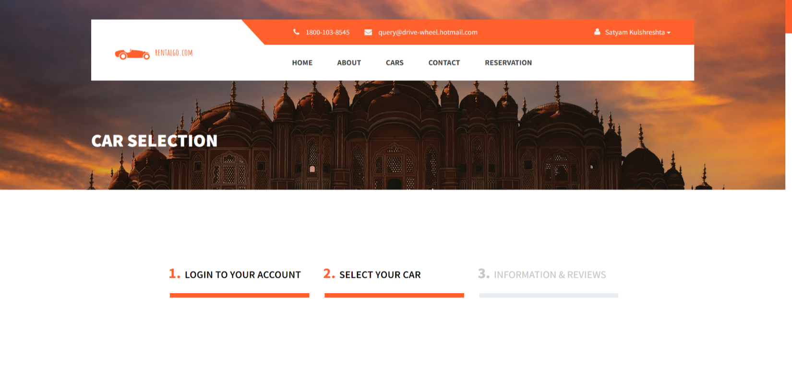**Cars Page**

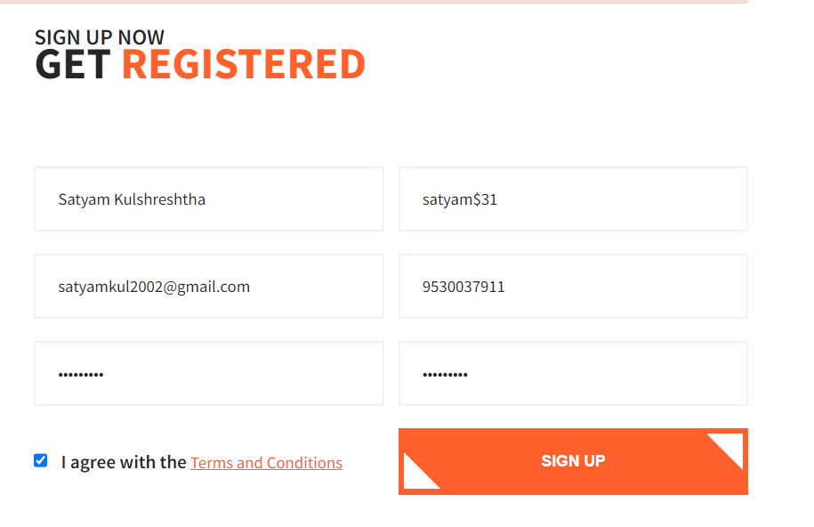**Registration and Log-in page**

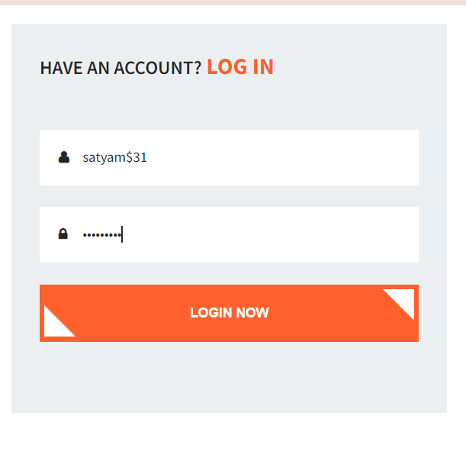

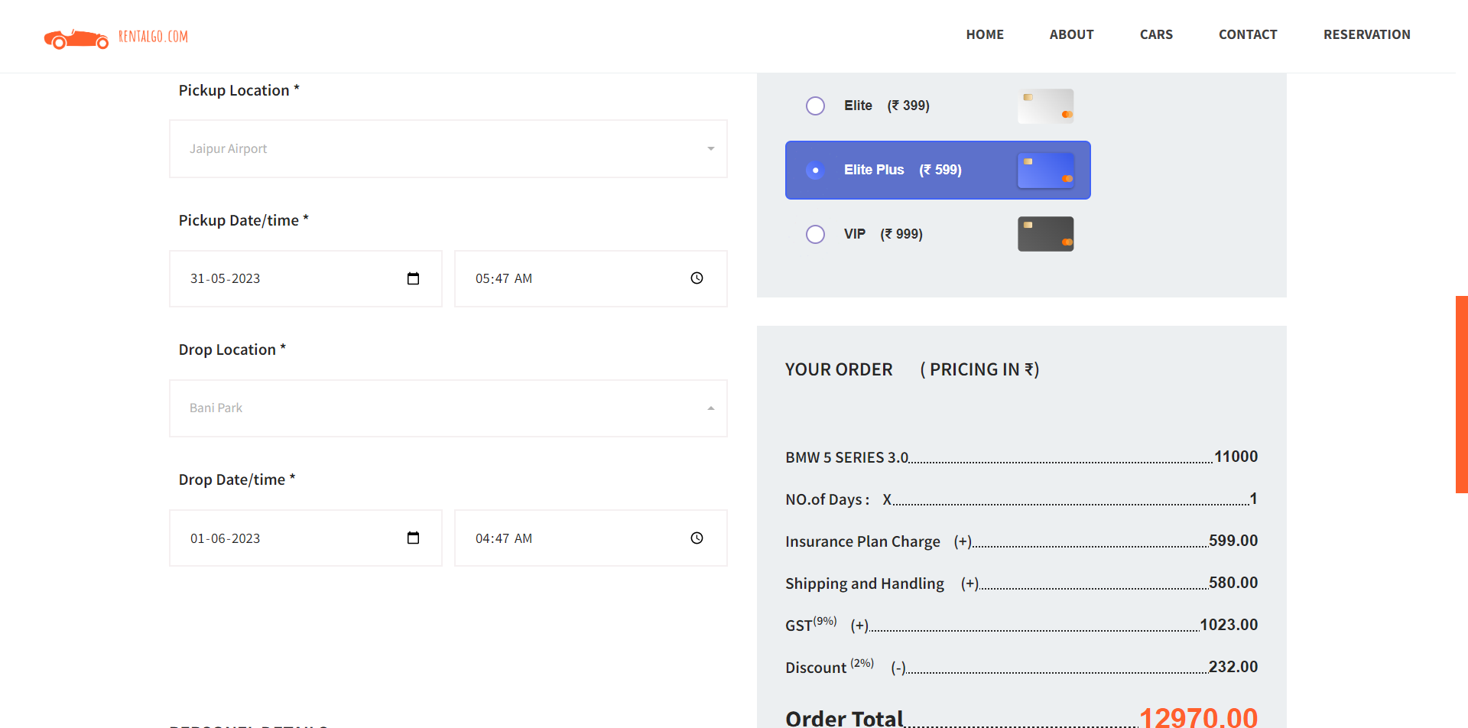**Booking page**

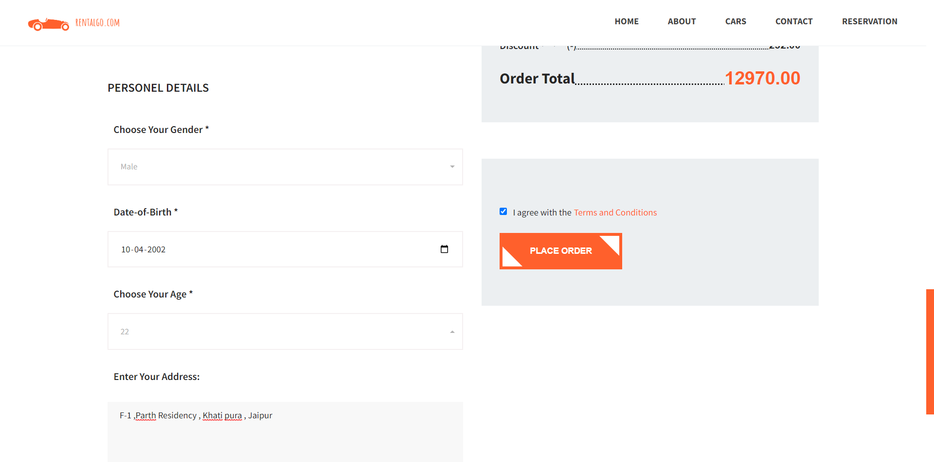

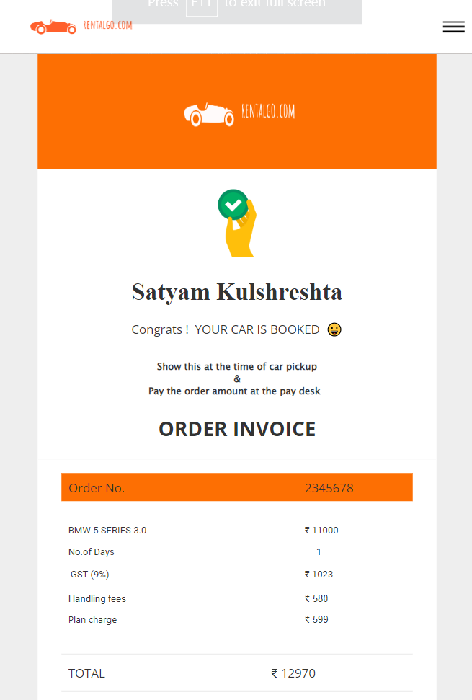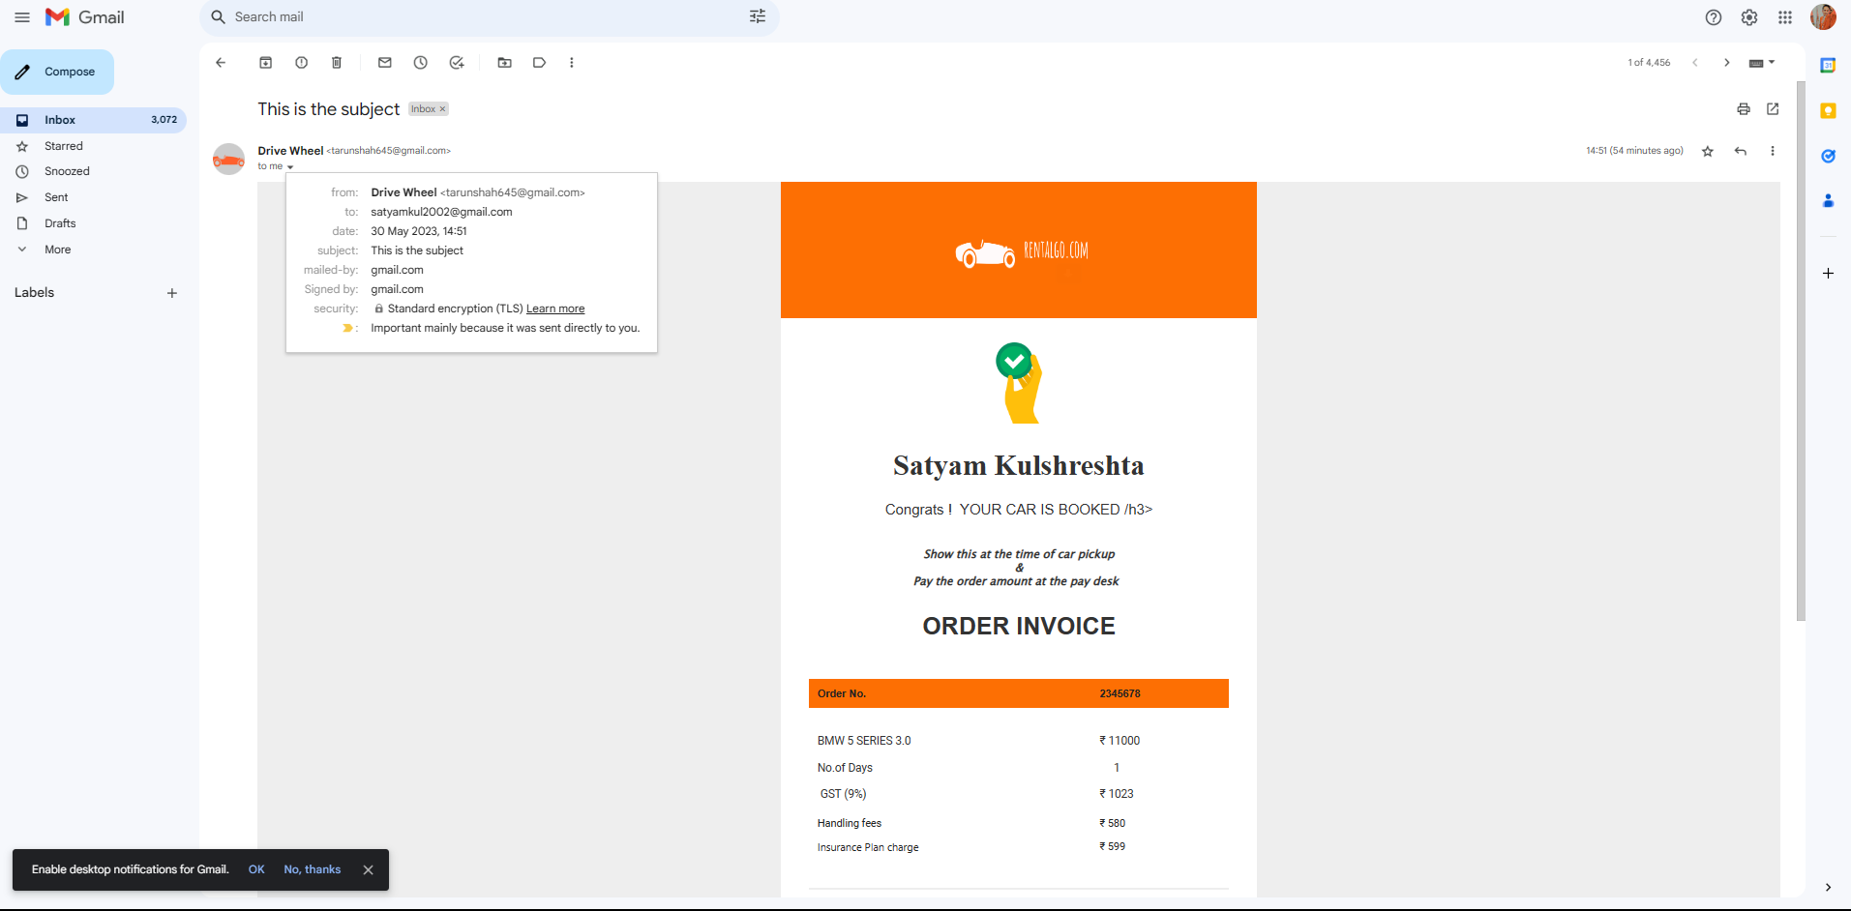**Booking Confirmation Page**

**Database Design**

The database design for the car rental website involves careful consideration of various factors to ensure efficient data management and retrieval. Here are more details about each component:

**Entity-Relationship Diagram (ERD):**

The Entity-Relationship Diagram (ERD) is a visual representation of the database structure. It illustrates the entities (tables), their attributes (columns), and the relationships between them. The ERD helps in understanding the database schema and the flow of data within the system. It provides a clear overview of the entities, their properties, and how they are connected, aiding in database design and maintenance.

**Database Schema:**

The database schema is the blueprint or structure of the database. It defines the tables, their fields (attributes), data types, constraints, and relationships. The schema provides a comprehensive view of the database, outlining the organization and layout of data. It serves as a reference for developers, administrators, and users to understand the database structure and the relationships between different entities.

**Tables and Relationships:**

Tables are the fundamental building blocks of a database. Each table represents an entity, such as users, cars, bookings, etc., and contains columns that represent the attributes of that entity. The relationships between tables define how the entities are associated with each other. For example, a one-to-many relationship exists between users and bookings, where one user can have multiple bookings.

**Data Validation and Integrity:**

Data validation ensures that only valid and accurate data is stored in the database. It involves defining constraints, such as data types, length limits, and format rules, to validate the data before it is inserted or updated in the database. Data integrity refers to maintaining the accuracy and consistency of data throughout the database. This is achieved through constraints like primary keys, foreign keys, unique constraints, and referential integrity rules.

**SQL Queries and Database Operations:**

SQL (Structured Query Language) is used to interact with the database and perform various operations such as data retrieval, insertion, updating, and deletion. SQL queries are written to fetch specific data based on conditions, join tables to retrieve related information, and aggregate data for analysis. Database operations include creating tables, defining relationships, indexing, optimizing queries, and managing database transactions.

These components play a crucial role in the database design and implementation for the car rental website. The ERD provides a visual representation of the database structure, the schema defines the tables and their attributes, relationships determine the connections between entities, data validation ensures the integrity of data, and SQL queries and operations facilitate data manipulation and retrieval. Together, these elements contribute to the efficient storage, retrieval, and management of data in the car rental website's database.

**Tables and Fields:**

Each entity identified in the ER diagram corresponds to a table in the database. Tables are created to store specific types of data. For example, the "Users" table stores user-related information, such as user ID, name, email, and password. The "Cars" table stores details about each car available for rent, such as car ID, brand, model, mileage, and rental price.

**Primary Keys and Foreign Keys:**

Primary keys uniquely identify each record within a table. For instance, the user ID in the "Users" table serves as the primary key. Foreign keys establish relationships between tables by referencing the primary key of another table. For example, the "Bookings" table may have a foreign key referencing the user ID from the "Users" table to associate bookings with specific users.

**Normalization:**

The database design follows normalization principles to eliminate redundancy and ensure data consistency. This involves breaking down data into smaller, logical units and avoiding data duplication. For example, instead of storing user information in multiple tables, user details are stored in a separate "Users" table and referenced using foreign keys.

**Indexing:**

Indexes are created on certain fields to enhance query performance. By indexing frequently searched or joined fields, the database can quickly locate and retrieve the desired data. Indexing can significantly improve the speed of data retrieval operations, making the website more responsive to user queries.

**Data Relationships and Constraints:**

Data relationships are established using constraints such as foreign key constraints. These constraints enforce referential integrity, ensuring that data remains consistent across related tables. For example, a foreign key constraint on the "Bookings" table ensures that only valid user IDs from the "Users" table can be associated with bookings.

**SQL Queries and Stored Procedures:**

SQL queries are used to interact with the database, allowing for data retrieval, insertion, update, and deletion. These queries are written to perform various operations, such as retrieving available cars, updating car availability after a booking, or calculating rental charges based on user inputs. Stored procedures can be implemented to encapsulate complex business logic and improve performance.

**Database Diagrams**

**Class Diagram:**

Steps to create an ER diagram for car rental website project are :

1. Identify the entities. The first step is to identify the entities in your system. An entity is a person, place, thing, or event that your system will store information about. In this case, some of the entities might include:
   * Customers
   * Cars
   * Rentals
2. Identify the relationships. Once you have identified the entities, you need to identify the relationships between them. A relationship is a connection between two entities. In this case, some of the relationships might include:
   * A customer can rent a car.
   * A car can be rented by multiple customers.
3. Identify the attributes. Once you have identified the entities and the relationships, you need to identify the attributes of each entity. An attribute is a piece of information about an entity. In this case, some of the attributes for customers might include:
   * Name
   * Address
   * Phone number
4. Create the ER diagram. Once you have identified the entities, the relationships, and the attributes, you can create the ER diagram. The diagram will show the entities, the relationships between them, and the attributes of each entity.

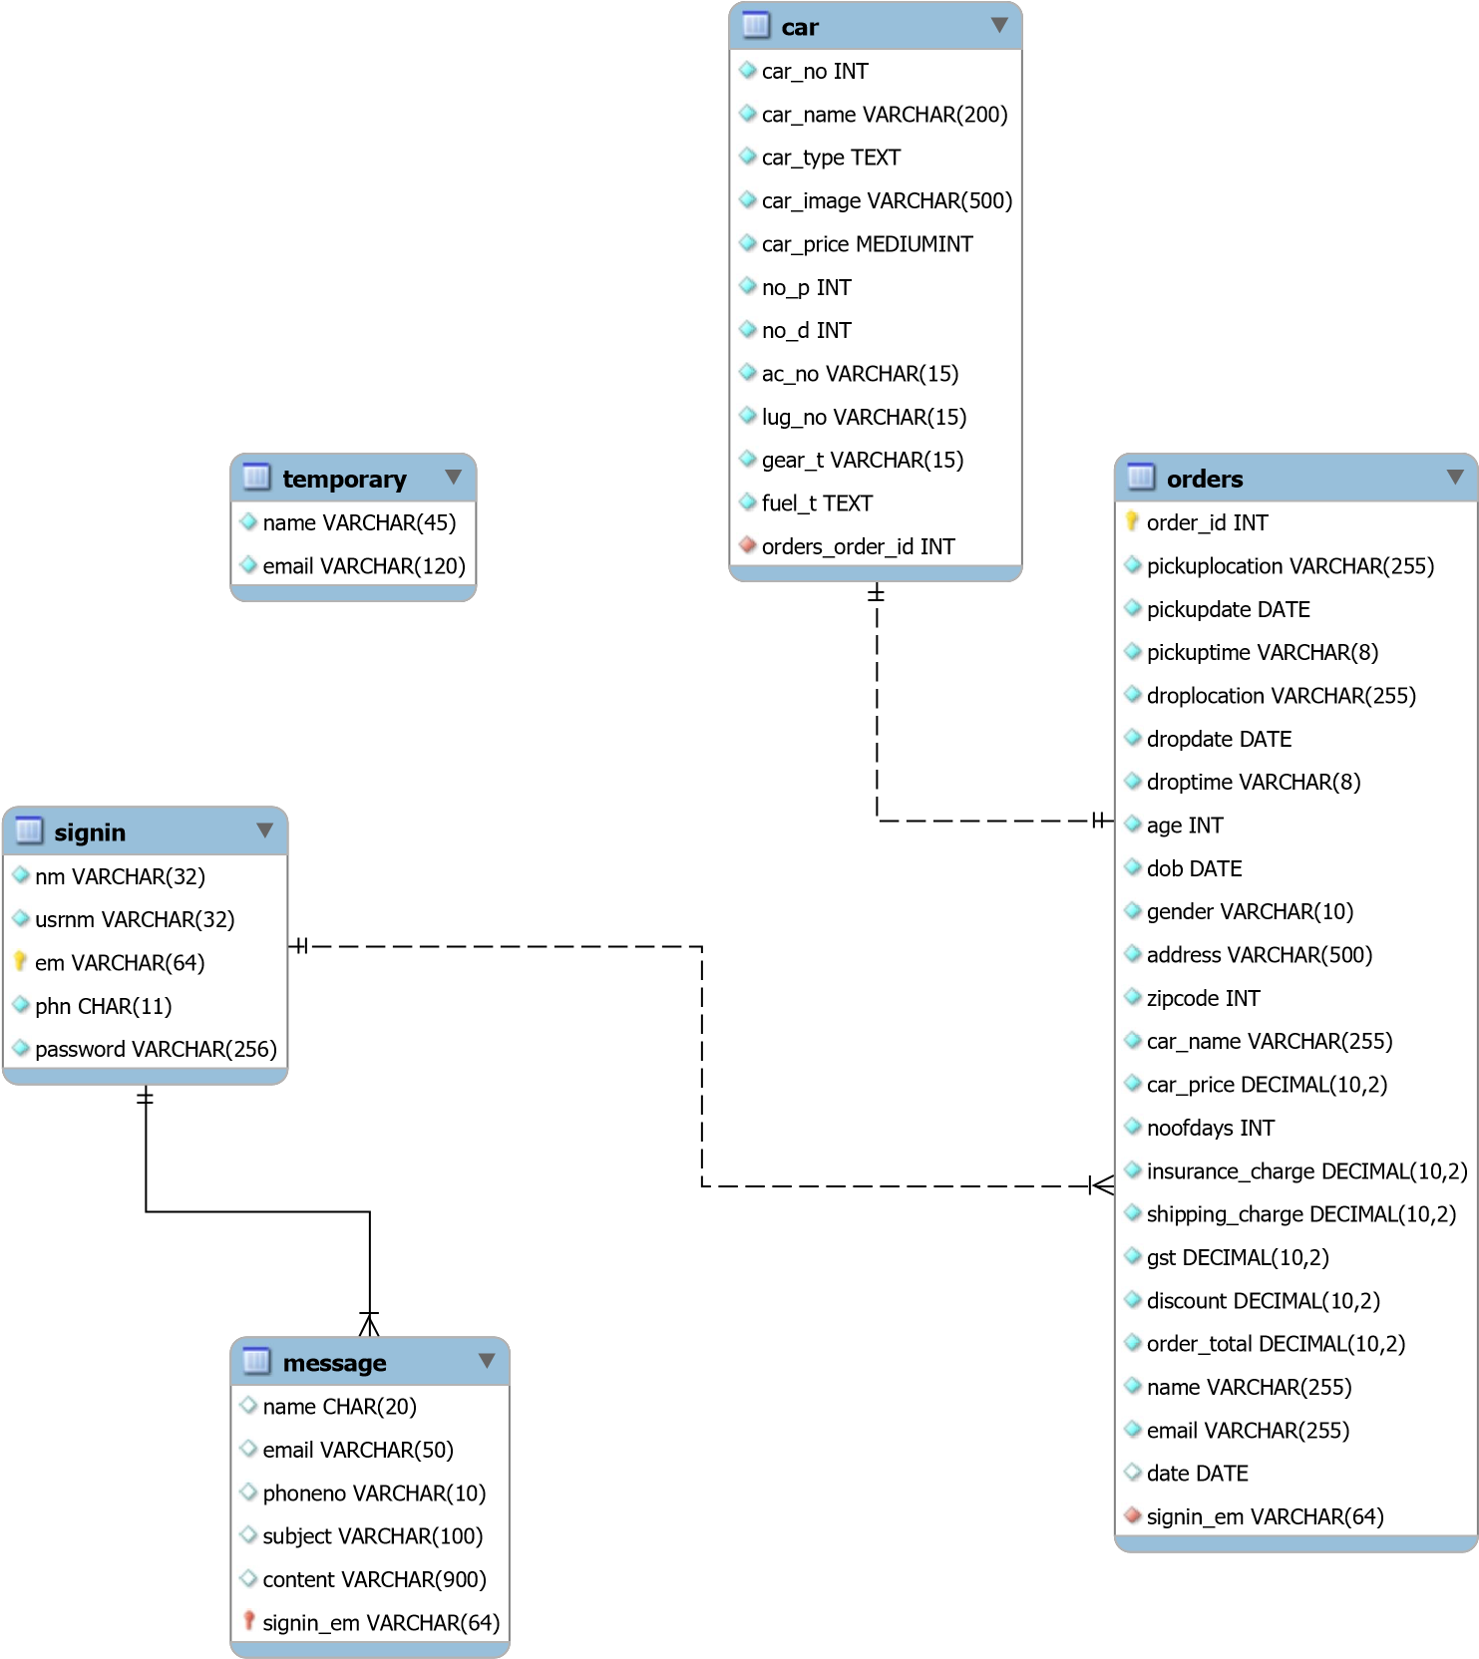

**MYSQL DIALECT FOR DATABASE TABLES**

1. **Car Table:**

The provided SQL statement creates a table named `car` with the following columns:

* + `car_no` (int): This column stores the unique identification number of the car. It is of type integer and is not allowed to be null (NOT NULL).
  + `car_name` (varchar(200)): This column stores the name or title of the car. It is of type varchar with a maximum length of 200 characters. It is not allowed to be null.
  + `car_type` (text): This column stores the type or category of the car. It is of type text and is not allowed to be null.
  + `car_image` (varchar(500)): This column stores the file path or URL of the car's image. It is of type varchar with a maximum length of 500 characters. It is not allowed to be null.
  + `car_price` (mediumint): This column stores the price or cost of renting the car. It is of type mediumint, which represents a medium-sized integer. It is not allowed to be null.
  + `no_p` (int): This column stores the maximum number of passengers the car can accommodate. It is of type integer and is not allowed to be null.
  + `no_d` (int): This column stores the maximum number of days the car can be rented. It is of type integer and is not allowed to be null.
  + `ac_no` (varchar(15)): This column stores the air conditioning system number of the car. It is of type varchar with a maximum length of 15 characters. It is not allowed to be null.
  + `lug_no` (varchar(15)): This column stores the luggage number of the car. It is of type varchar with a maximum length of 15 characters. It is not allowed to be null.
  + `gear_t` (varchar(15)): This column stores the type of gear transmission of the car. It is of type varchar with a maximum length of 15 characters. It is not allowed to be null.
  + `fuel_t` (text): This column stores the fuel type of the car. It is of type text and is not allowed to be null.

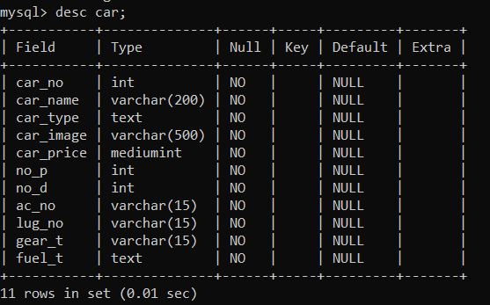

1. **Sign in Table:**

The provided SQL statement creates a table named `signin` with the following columns:

* + `nm` (varchar(32)): This column stores the name of the user. It is of type varchar with a maximum length of 32 characters. It is not allowed to be null.
  + `usrnm` (varchar(32)): This column stores the username of the user. It is of type varchar with a maximum length of 32 characters. It is not allowed to be null.
  + `em` (varchar(64)): This column stores the email address of the user. It is of type varchar with a maximum length of 64 characters. It is not allowed to be null.
  + `phn` (char(11)): This column stores the phone number of the user. It is of type char with a fixed length of 11 characters. It is not allowed to be null.
  + `password` (varchar(256)): This column stores the password of the user. It is of type varchar with a maximum length of 256 characters. It is not allowed to be null.

The table also defines two keys:

* + `PRIMARY KEY`: The primary key is set on the `em` (email) column, which ensures each email address is unique and serves as the primary identifier for each user.
  + `UNIQUE KEY`: The unique key is set on the `usrnm` (username) column, which ensures that each username is unique.

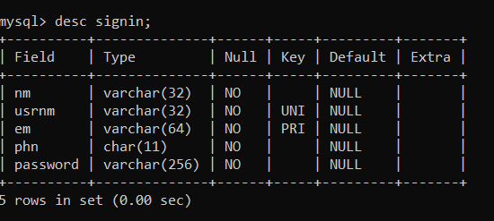

1. **Orders Table:**

The provided SQL statement creates a table named `orders` with the following columns:

* + `order_id` (int): This column serves as the primary key and is auto-incremented for each new order.
  + `pickuplocation` (varchar(255)): This column stores the pickup location for the car rental. It is of type varchar with a maximum length of 255 characters. It is not allowed to be null.
  + `pickupdate` (date): This column stores the pickup date for the car rental. It is of type date and is not allowed to be null.
  + `pickuptime` (varchar(8)): This column stores the pickup time for the car rental. It is of type varchar with a maximum length of 8 characters. It is not allowed to be null.
  + `droplocation` (varchar(255)): This column stores the drop-off location for the car rental. It is of type varchar with a maximum length of 255 characters. It is not allowed to be null.
  + `dropdate` (date): This column stores the drop-off date for the car rental. It is of type date and is not allowed to be null.
  + `droptime` (varchar(8)): This column stores the drop-off time for the car rental. It is of type varchar with a maximum length of 8 characters. It is not allowed to be null.
  + `age` (int): This column stores the age of the person renting the car. It is of type int and is not allowed to be null.
  + `dob` (date): This column stores the date of birth of the person renting the car. It is of type date and is not allowed to be null.
  + `gender` (varchar(10)): This column stores the gender of the person renting the car. It is of type varchar with a maximum length of 10 characters. It is not allowed to be null.
  + `address` (varchar(500)): This column stores the address of the person renting the car. It is of type varchar with a maximum length of 500 characters. It is not allowed to be null.
  + `zipcode` (int): This column stores the ZIP code of the person renting the car. It is of type int and is not allowed to be null.
  + `car_name` (varchar(255)): This column stores the name of the car being rented. It is of type varchar with a maximum length of 255 characters. It is not allowed to be null.
  + `car_price` (decimal(10,2)): This column stores the price of the car rental. It is of type decimal with a precision of 10 and scale of 2. It is not allowed to be null.
  + `noofdays` (int): This column stores the number of days for the car rental. It is of type int and is not allowed to be null.
  + `insurance_charge` (decimal(10,2)): This column stores the charge for insurance. It is of type decimal with a precision of 10 and scale of 2. It is not allowed to be null.
  + `shipping_charge` (decimal(10,2)): This column stores the charge for shipping. It is of type decimal with a precision of 10 and scale of 2. It is not allowed to be null.
  + `gst` (decimal(10,2)): This column stores the GST (Goods and Services Tax) for the car rental. It is of type decimal with a precision of 10 and scale of 2. It is not allowed to be null.
  + `discount` (decimal(10,2)): This column stores the discount applied to the car rental. It is of type decimal with a precision of 10 and scale.

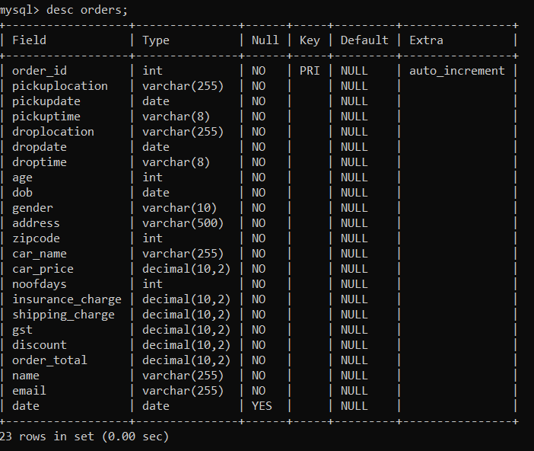

1. **Message Table:**

The provided SQL statement creates a table named `message` with the following columns:

* + `name` (char(20)): This column stores the name of the person sending the message. It is of type char with a length of 20 characters. It is allowed to be null.
  + `email` (varchar(50)): This column stores the email address of the person sending the message. It is of type varchar with a length of 50 characters. It is allowed to be null.
  + `phoneno` (varchar(10)): This column stores the phone number of the person sending the message. It is of type varchar with a length of 10 characters. It is allowed to be null.
  + `subject` (varchar(100)): This column stores the subject of the message. It is of type varchar with a length of 100 characters. It is allowed to be null.
  + `content` (varchar(900)): This column stores the content or body of the message. It is of type varchar with a length of 900 characters. It is allowed to be null.

The `DEFAULT NULL` indicates that if no value is provided for a column when inserting a new row, the default value will be set as NULL.

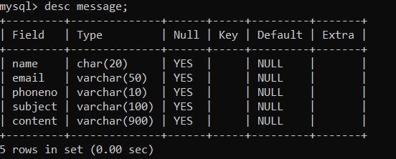

1. **Temporary Table:**

The provided SQL statement creates a table named `temporary` with the following columns:

* + `name` (varchar(45)): This column stores the name of the user. It is of type varchar with a length of 45 characters. It is not allowed to be null.
  + `email` (varchar(120)): This column stores the email address of the user. It is of type varchar with a length of 120 characters. It is not allowed to be null.

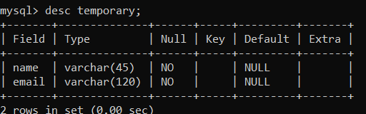

**Backend Development**

Backend development plays a critical role in the functioning and data processing of the car rental website. As the developer of the project, I have utilized various technologies and techniques to ensure efficient and secure backend operations.

**Java Servlets:**

Java Servlets are used to handle HTTP requests and responses. In the car rental website, Java Servlets are responsible for managing user interactions, such as user registration, login, and booking requests. They handle the communication between the frontend and the backend, ensuring seamless data exchange.

**Java Server Pages (JSP):**

Java Server Pages (JSP) are used for dynamic content generation in the car rental website. JSP allows the integration of Java code within HTML pages, enabling the rendering of dynamic content. In the car rental website, JSP is utilized to display user-specific information, such as rental history, account details, and booking confirmation.

**Enterprise JavaBeans (EJB):**

Enterprise JavaBeans (EJB) is a component-based architecture used for implementing the business logic of the car rental website. EJB provides a framework for building scalable and robust enterprise applications. In the car rental website, EJB components are used to manage business rules, perform complex calculations, and interact with other components.

**Business Logic Implementation:**

The backend development involves implementing the business logic of the car rental website. This includes handling the pricing, availability, and booking rules for the vehicles. The business logic ensures that users can search for available cars, select dates and locations, calculate rental prices, and make bookings based on predefined rules and constraints.

**Integration with Database (JDBC):**

The car rental website requires seamless integration with a database to store and retrieve data. Java Database Connectivity (JDBC) is used to establish a connection with the database, execute queries, and retrieve or update data. JDBC ensures that user information, vehicle details, booking history, and other relevant data are stored and accessed securely and efficiently.

**Handling User Requests and Data Processing:**

Backend development involves handling user requests and processing data in a secure and efficient manner. This includes validating user inputs, performing necessary computations, and interacting with the database to retrieve or update information. User requests for vehicle availability, booking confirmations, and payment processing are processed and managed by the backend components.

By utilizing Java Servlets, JSP, EJB, JDBC, and implementing the necessary business logic, the backend of the car rental website ensures smooth operations, data integrity, and secure processing of user requests. The backend development enables seamless communication between the frontend and the database, allowing users to interact with the website effectively and facilitating the smooth functioning of car rental services.

There Are 4s backend servlets:

* Login.java
* Register.java
* Reservation.java
* Message.java

**System Testing**

System testing is a crucial phase in the development of the car rental website to ensure its functionality, reliability, and user-friendliness. As the developer of the project, I have implemented the following system testing practices to ensure the quality and performance of the website.

**Testing Approach and Methodology:**

The testing approach for the car rental website follows a structured methodology. It includes a combination of manual and automated testing techniques to evaluate different aspects of the system. The testing process involves creating test scenarios, executing test cases, and analyzing the results to identify and resolve any issues.

**Test Plan and Test Cases:**

A comprehensive test plan has been developed to outline the objectives, scope, and strategies for testing the car rental website. It identifies the key functionalities and features to be tested, along with the test environment setup and necessary resources. Test cases have been designed to cover various scenarios, such as user registration, vehicle booking, payment processing, and error handling. Each test case specifies the input data, expected output, and any preconditions or postconditions.

**Unit Testing:**

Unit testing focuses on testing individual components and modules of the car rental website. It involves verifying the correctness and reliability of functions, classes, and methods. Unit tests have been implemented to validate the functionality of each component, ensuring that they work as expected. This testing approach helps identify and fix any defects or errors early in the development process.

**Integration Testing:**

Integration testing is performed to assess the interaction and compatibility of different modules within the car rental website. It aims to ensure that all components work together seamlessly. Integration tests verify the proper functioning of interfaces, data exchange between modules, and the overall system behavior. This testing phase helps identify and resolve any issues that may arise during the integration process.

**User Acceptance Testing:**

User Acceptance Testing (UAT) is conducted to evaluate the car rental website from the end user's perspective. Real users or stakeholders are involved in testing the website in a simulated production environment. UAT aims to ensure that the website meets user requirements, usability standards, and performance expectations. Feedback from users is collected and analyzed to make necessary improvements and address any issues or concerns.

**Bug Tracking and Issue Resolution:**

During the testing process, any identified bugs, defects, or issues are logged and tracked using a bug tracking system. Each issue is assigned a priority and severity level. The development team investigates and resolves the reported issues, ensuring that the website's functionality is enhanced, and any problems are addressed. Regular communication and collaboration among the development team help ensure timely bug resolution.

By implementing a comprehensive system testing approach, including test planning, test case development, unit testing, integration testing, user acceptance testing, and effective bug tracking and issue resolution, the car rental website can be thoroughly evaluated for quality and performance. This systematic testing process helps identify and rectify any issues, ensuring a reliable and user-friendly website for car rental services.

**Project Implementation and Results**

**Project Timeline and Milestones:**

The development of the car rental website followed a structured timeline with defined milestones. The project timeline included phases such as requirement gathering, design, development, testing, and deployment. Each phase had specific objectives and deliverables, ensuring a systematic approach to project implementation. Milestones, such as the completion of UI design, backend development, database integration, and testing, were achieved within the planned timeframe.

**Challenges Faced and Solutions:**

During the implementation of the car rental website, certain challenges were encountered, and appropriate solutions were devised to overcome them. One challenge was integrating third-party APIs for real-time availability and pricing information of vehicles. The solution involved thorough research, understanding the API documentation, and implementing the necessary code to fetch and display accurate data. Another challenge was ensuring secure payment processing. This was addressed by implementing industry-standard encryption protocols and partnering with a trusted payment gateway provider

**Results and Achievements:**

The implementation of the car rental website has yielded significant results and achievements. The website successfully provides users with an intuitive and user-friendly interface for searching and booking rental cars. Users can easily browse available vehicles, view detailed information, select dates and locations, and complete the booking process seamlessly. The integration with the backend and database allows for efficient data processing, ensuring accurate availability and pricing information. The project has achieved its objective of developing a functional and reliable car rental website.

**User Feedback and Evaluation:**

User feedback and evaluation have played a crucial role in assessing the success of the car rental website. Feedback from users has been positive, highlighting the ease of use, responsive design, and comprehensive search functionalities. Users have appreciated the seamless booking process and the availability of relevant vehicle details. Feedback has also been gathered regarding any areas of improvement, such as additional filtering options or enhanced payment methods. This feedback has been valuable in identifying areas for further enhancements and future iterations of the car rental website.

Overall, the project implementation has been successful in delivering a functional and user-friendly car rental website. The adherence to the project timeline, the effective resolution of challenges, the achievement of milestones, and the positive user feedback are indicators of a well-executed project. The car rental website has demonstrated its ability to provide a reliable and efficient platform for users to search, book, and manage rental car services, contributing to a seamless user experience.

**Conclusion**

**Project Summary:**

In conclusion, the development of the car rental website has been a significant undertaking that has successfully resulted in the creation of a fully functional and user-friendly platform for renting cars online. The project encompassed various aspects, including user interface design, database development, backend implementation, and system testing. By leveraging the power of technologies such as HTML, CSS, JavaScript, Java EE, and MySQL, we have been able to deliver a robust and reliable solution that meets the requirements of a modern car rental service.

**Lessons Learned:**

Throughout the project, several valuable lessons were learned. We gained a deeper understanding of web development principles and best practices, as well as the importance of effective project management and collaboration. We learned the significance of conducting thorough testing at each stage of the development process to identify and address any issues or bugs. Additionally, we realized the importance of soliciting and incorporating user feedback to continually improve the website and enhance the user experience.

**Future Enhancements:**

While the car rental website has been successfully developed and deployed, there are potential areas for future enhancements. One aspect is the implementation of additional features such as user accounts, which would allow users to save their preferences and manage their bookings more effectively. Integration with external APIs to provide additional services such as GPS navigation or real-time weather updates could also enhance the user experience. Furthermore, expanding the availability of the website to support multiple languages and currencies could attract a broader user base.

Overall, the completion of the car rental website project has been a fulfilling experience. It has provided us with the opportunity to apply our knowledge and skills in web development and showcase our ability to deliver a high-quality software solution. The project has enabled us to gain practical experience in working with various technologies and has deepened our understanding of the challenges.

**Bibliography**

**1. W3Schools.** HTML Tutorial. Retrieved from https://www.w3schools.com/html/

**2. W3Schools.** CSS Tutorial. Retrieved from https://www.w3schools.com/css/

**3. JavaScript**. MDN Web Docs. Retrieved from https://developer.mozilla.org/en-US/docs/Web/JavaScript

**4. jQuery**. jQuery Documentation. Retrieved from https://jquery.com/

**5. Bootstrap**. Bootstrap Documentation. Retrieved from https://getbootstrap.com/

**6. Oracle**. Java EE Documentation. Retrieved from https://docs.oracle.com/javaee/

**7. JDBC**. Oracle JDBC Documentation. Retrieved from https://docs.oracle.com/javase/8/docs/technotes/guides/jdbc/

**8. EJB**. Oracle EJB Documentation. Retrieved from https://docs.oracle.com/javaee/7/tutorial/ejb-intro.htm

**9. HTTP**. MDN Web Docs. Retrieved from https://developer.mozilla.org/en-US/docs/Web/HTTP

**10. MySQL**. MySQL Documentation. Retrieved from https://dev.mysql.com/doc/

**11. Apache Tomcat**. Apache Tomcat Documentation. Retrieved from https://tomcat.apache.org/tomcat-9.0-doc/

**12. Oracle**. Java SE Documentation. Retrieved from https://docs.oracle.com/javase/

**13. YouTube**.

**14. Wikipedia**.

**15. Chat GPT**. Open AI. Retrieved from https://www.openai.com/